PROJECT REPORT
Real-Time Object Detection, Tracking, and Speed Estimation Using an Arduino-Based Ultrasonic Radar System with Bare-Metal Register Programming


Spring 2026
CSE-L Embeded Systems Lab
Submitted by: Naveed Ahmad(22PWCSE2165)
Jamal Khan (22PWCSE2203)
Maaz Muhammad (22PWCSE2177)
Semester: 8th
Section: B

Student Signature: ______________

Submitted to:
Engr. Muhammad Shahzad
(Jul 1, 2026)

Department of Computer Systems Engineering
University of Engineering and Technology, Peshawar

Project Title
Real-Time Object Detection, Tracking, and Speed Estimation Using an Arduino-Based Ultrasonic Radar System with Bare-Metal Register Programming
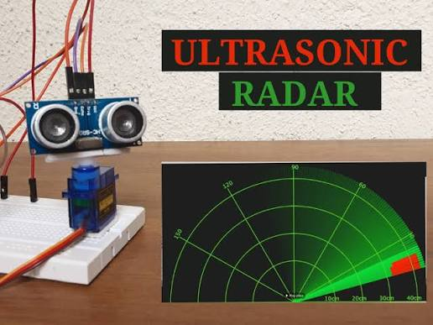
1. ABSTRACT
This project presents a real-time ultrasonic radar system developed using the Arduino Uno (ATmega328P). The system combines an HC-SR04 ultrasonic sensor with an SG90 servo motor to scan the surrounding environment over a predefined angular range. Distance measurements are transmitted to a computer through UART communication, where a Processing IDE application displays a real-time radar interface. Unlike conventional ultrasonic radar systems, the proposed design also estimates the approximate speed of moving objects by comparing consecutive distance measurements over time. To improve understanding of embedded systems, the project utilizes bare-metal register programming for hardware control instead of relying entirely on Arduino library functions.

2. Objectives
- Design a real-time ultrasonic radar system.
- Detect objects using the HC-SR04 ultrasonic sensor.
- Rotate the sensor using a servo motor for 180° area scanning.
- Estimate the speed of moving objects.
- Transmit data using UART serial communication.
- Display detected objects on a graphical radar interface.
- Demonstrate bare-metal programming on the ATmega328P

3. Hardware Components
Component | Quantity
Arduino Uno (ATmega328P) | 1
HC-SR04 Ultrasonic Sensor | 1
SG90 Servo Motor | 1
Breadboard | 1
Jumper Wires | Several
USB Cable | 1
Laptop

4. Software Tools
- Arduino IDE
- Processing IDE
- Embedded C/C++
- Processing (Java)
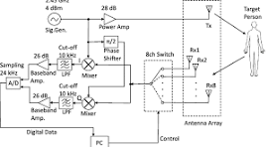

5. System Working
The servo motor continuously rotates the ultrasonic sensor between 15° and 165°. At each angle, the HC-SR04 measures the distance to nearby objects using ultrasonic echo timing. The Arduino computes the object’s distance and periodically compares successive readings to estimate the object’s speed. The calculated angle and distance are transmitted through UART serial communication. A Processing IDE application receives the serial data and displays a real-time radar interface that visualizes object positions during scanning.
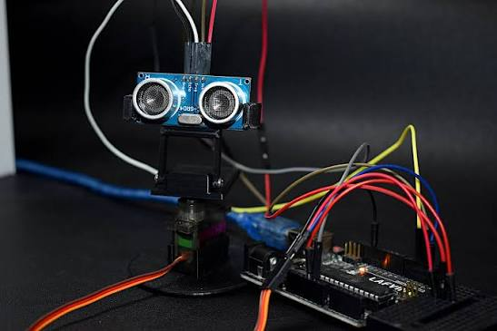

6. System Flow
- Initialize peripherals.
- Rotate servo to the next angle.
- Trigger ultrasonic sensor.
- Measure echo pulse duration.
- Calculate object distance.
- Compare consecutive readings to estimate speed.
- Send angle, distance, and speed via UART.
- Update radar display in Processing IDE.
- Repeat scanning cycle.
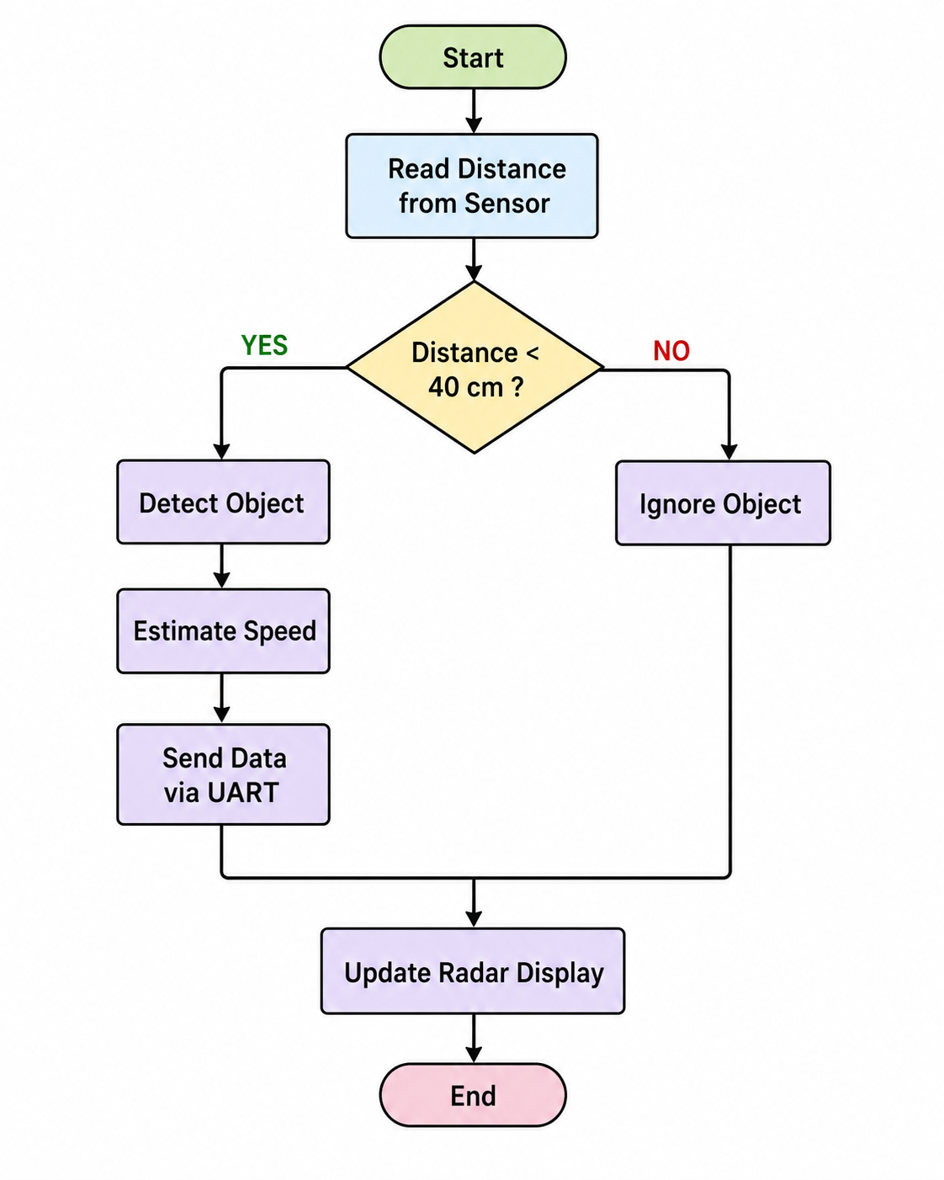

7. Features
- Real-time object detection
- 150° radar scanning
- Approximate object speed estimation
- UART serial communication
- Graphical radar visualization
- Bare-metal ATmega328P register programming
- Low-cost and portable design

8. Applications
- Obstacle detection
- Robot navigation
- Smart surveillance
- Educational embedded systems laboratories
- Motion monitoring
- Autonomous robotics

9. Conclusion
The developed ultrasonic radar system successfully performs real-time object detection, tracking, and approximate speed estimation using low-cost hardware. By integrating ultrasonic sensing, servo-based scanning, UART communication, and a Processing-based graphical interface, the project demonstrates practical embedded system design. The use of bare-metal register programming provides a deeper understanding of ATmega328P peripherals and embedded hardware control while maintaining reliable system performance.
- Ardiuno Code Register Base:

/*

* Real-Time Object Detection, Tracking, and Speed Estimation

* Using Arduino-Based Ultrasonic Radar System

* with Bare-Metal ATmega328P Register Programming

*

* Hardware:

* HC-SR04 Trigger -> D10 (PB2)

* HC-SR04 Echo -> D11 (PB3)

* SG90 Servo -> D12 (PB4)

* UART TX -> D1 (PD1) [9600 baud to Processing GUI]

*

* Output format (compatible with Processing radar sketch):

* angle,distance.

* e.g. 45,32.

*/

#ifndef F_CPU

#define F_CPU 16000000UL

#endif

#include <avr/io.h>

#include <avr/interrupt.h>

#include <stdint.h>

#include <stdbool.h>

// ============================================================================

// CONFIGURATION

// ============================================================================

#define BAUD_RATE 9600UL

#define UBRR_VALUE ((F_CPU / (16UL * BAUD_RATE)) - 1) // = 103

// Timer1 runs at F_CPU/8 = 2 MHz -> 1 count = 0.5 us

// For 50 Hz servo PWM we need a 20 ms period:

// TOP = (20000 us / 0.5 us) - 1 = 39999

#define SERVO_TIMER_TOP 39999

// SG90 pulse widths mapped to Timer1 counts (1 count = 0.5 us):

// 0 deg = 1000 us = 2000 counts

// 180 deg = 2000 us = 4000 counts

#define SERVO_PULSE_0DEG 2000

#define SERVO_PULSE_180DEG 4000

// Sweep limits and step delay

#define SWEEP_MIN_ANGLE 15

#define SWEEP_MAX_ANGLE 165

#define SERVO_STEP_DELAY_MS 30 // ms to wait after each 1-degree move

// HC-SR04 valid echo range

#define ECHO_MIN_US 116UL // ~2 cm

#define ECHO_MAX_US 23200UL // ~400 cm

// ============================================================================

// SHARED STATE (written by ISRs, read by main loop)

// ============================================================================

volatile uint32_t g_micros = 0; // incremented every 1 us by Timer0

volatile uint32_t g_echo_rise_us = 0; // timestamp of echo rising edge

volatile uint32_t g_echo_fall_us = 0; // timestamp of echo falling edge

volatile bool g_echo_active = false; // true while echo pin is HIGH

volatile bool g_echo_ready = false; // true when a full pulse is captured

// ============================================================================

// INTERRUPT SERVICE ROUTINES

// ============================================================================

/*

* Timer0 Compare Match A — fires every 1 us

*

* Timer0 is configured in CTC mode with prescaler /8 and OCR0A = 1.

* At 16 MHz / 8 = 2 MHz clock, the counter ticks every 0.5 us.

* With TOP = 1 the counter resets every 2 ticks = 1 us.

* This gives us a software microsecond counter equivalent to Arduino's micros().

*/

ISR(TIMER0_COMPA_vect)

{

g_micros++;

}

/*

* Timer1 Overflow — fires at the START of every 20 ms servo PWM frame

*

* In Fast PWM Mode 14 (TOP = ICR1), the overflow flag sets when TCNT1

* wraps from ICR1 back to 0. We use this moment to drive the servo

* signal pin HIGH, beginning the pulse.

*/

ISR(TIMER1_OVF_vect)

{

PORTB |= (1 << PB4); // servo signal HIGH — pulse begins

}

/*

* Timer1 Compare Match A — fires when TCNT1 reaches OCR1A

*

* OCR1A holds the pulse-width value for the current servo angle.

* When the counter reaches this value we drive the servo pin LOW,

* ending the pulse. The pin stays LOW for the rest of the 20 ms frame.

*/

ISR(TIMER1_COMPA_vect)

{

PORTB &= ~(1 << PB4); // servo signal LOW — pulse ends

}

/*

* Pin Change Interrupt — Port B (PCINT0_vect handles PB0..PB7)

*

* We have enabled only PCINT3 (PB3 = D11 = ECHO pin).

* This ISR fires on both the rising edge (echo start) and the

* falling edge (echo end). We read PINB to determine which edge

* just occurred, then record the current microsecond timestamp.

*

* The pulse duration (g_echo_fall_us - g_echo_rise_us) is later

* converted to a distance in the main loop.

*/

ISR(PCINT0_vect)

{

if (PINB & (1 << PB3))

{

// Rising edge: HC-SR04 began sending the echo

g_echo_rise_us = g_micros;

g_echo_active = true;

g_echo_ready = false;

}

else if (g_echo_active)

{

// Falling edge: echo reception complete

g_echo_fall_us = g_micros;

g_echo_active = false;

g_echo_ready = true;

}

}

// ============================================================================

// UART (9600 8N1, TX only, bare register implementation)

// ============================================================================

static void uart_init(void)

{

// Set baud rate registers

// UBRR = F_CPU / (16 * baud) - 1 = 103 for 9600 baud @ 16 MHz

UBRR0H = (uint8_t)(UBRR_VALUE >> 8);

UBRR0L = (uint8_t)(UBRR_VALUE);

// UCSR0A: normal speed (U2X0 = 0), no multi-processor mode

UCSR0A = 0x00;

// UCSR0B: enable transmitter only

UCSR0B = (1 << TXEN0);

// UCSR0C: asynchronous UART, no parity, 1 stop bit, 8 data bits

UCSR0C = (1 << UCSZ01) | (1 << UCSZ00);

}

// Block until the UART data register is empty, then send one byte

static void uart_transmit_byte(uint8_t byte)

{

while (!(UCSR0A & (1 << UDRE0)));

UDR0 = byte;

}

// Transmit a uint16_t as decimal ASCII characters (no leading zeros)

static void uart_transmit_number(uint16_t value)

{

char digits[6]; // max 5 digits for uint16 + null terminator

int8_t index = 4;

digits[5] = '\0';

if (value == 0)

{

uart_transmit_byte('0');

return;

}

while (value > 0 && index >= 0)

{

digits[index--] = '0' + (uint8_t)(value % 10);

value /= 10;

}

// Send digits from first significant digit to index 4

for (int8_t i = index + 1; i <= 4; i++)

uart_transmit_byte((uint8_t)digits[i]);

}

// Send one radar data line: "angle,distance.\r\n"

static void uart_send_radar_line(uint8_t angle, uint16_t distance_cm)

{

uart_transmit_number(angle);

uart_transmit_byte(',');

uart_transmit_number(distance_cm);

uart_transmit_byte('.');

uart_transmit_byte('\r');

uart_transmit_byte('\n');

}

// ============================================================================

// MICROSECOND TIMER (Timer0, replaces Arduino micros() and delay())

// ============================================================================

static void timer0_init(void)

{

// CTC mode: TCNT0 counts 0, 1 then resets to 0 (TOP = OCR0A = 1)

TCCR0A = (1 << WGM01);

// TOP value: ISR fires every (OCR0A + 1) * prescaler / F_CPU seconds

// = 2 * 8 / 16000000 = 1 us

OCR0A = 1;

// Clock select: prescaler /8

TCCR0B = (1 << CS01);

// Enable Output Compare Match A interrupt

TIMSK0 = (1 << OCIE0A);

}

// Atomically read the 32-bit microsecond counter

static uint32_t micros_get(void)

{

uint32_t value;

cli();

value = g_micros;

sei();

return value;

}

// Busy-wait for the requested number of microseconds

static void delay_microseconds(uint32_t us)

{

uint32_t start = micros_get();

while ((micros_get() - start) < us);

}

// Busy-wait for the requested number of milliseconds

static void delay_milliseconds(uint32_t ms)

{

delay_microseconds(ms * 1000UL);

}

// ============================================================================

// SERVO (SG90, 50 Hz PWM via Timer1 Fast PWM Mode 14)

// ============================================================================

static void timer1_servo_init(void)

{

// Fast PWM Mode 14: WGM13=1 WGM12=1 WGM11=1 WGM10=0, TOP = ICR1

// OC1A pin (PB1/D9) is disconnected (COM1A = 00) because our servo

// is on PB4 (D12), which is not a hardware OC pin.

// We toggle PB4 manually from the OVF and COMPA ISRs instead.

TCCR1A = (1 << WGM11);

TCCR1B = (1 << WGM13) | (1 << WGM12) | (1 << CS11); // prescaler /8

// Set TOP for 20 ms PWM period (50 Hz)

ICR1 = SERVO_TIMER_TOP;

// Set initial pulse width for 15 degrees

OCR1A = SERVO_PULSE_0DEG +

((uint32_t)SWEEP_MIN_ANGLE *

(SERVO_PULSE_180DEG - SERVO_PULSE_0DEG)) / 180;

// Enable Overflow interrupt (pulse start) and Compare Match A (pulse end)

TIMSK1 = (1 << TOIE1) | (1 << OCIE1A);

}

// Convert an angle (0-180 degrees) to Timer1 counts and update OCR1A

static void servo_write(uint8_t angle)

{

uint16_t pulse_counts = SERVO_PULSE_0DEG +

((uint32_t)angle *

(SERVO_PULSE_180DEG - SERVO_PULSE_0DEG)) / 180;

// 16-bit register write must be atomic on AVR

cli();

OCR1A = pulse_counts;

sei();

}

// ============================================================================

// HC-SR04 ULTRASONIC SENSOR

// ============================================================================

static void echo_interrupt_init(void)

{

// Enable Pin Change Interrupts for Port B (covers PB0..PB7)

PCICR |= (1 << PCIE0);

// Unmask only PB3 (D11, ECHO pin) within Port B

PCMSK0 |= (1 << PCINT3);

}

// Send a 10 us HIGH pulse on the TRIG pin to start a measurement

static void hcsr04_trigger(void)

{

PORTB &= ~(1 << PB2); // ensure TRIG is LOW before trigger

delay_microseconds(2);

PORTB |= (1 << PB2); // TRIG HIGH for 10 us

delay_microseconds(10);

PORTB &= ~(1 << PB2); // TRIG LOW — sensor begins measurement

}

/*

* Trigger one HC-SR04 measurement and return distance in centimetres.

*

* The sensor responds by driving ECHO HIGH for a duration proportional

* to the round-trip time of the ultrasonic pulse.

* Distance (cm) = echo_duration_us / 58

*

* Returns 0 if no echo is received within 30 ms (out of range or absent).

*/

static uint16_t hcsr04_measure_cm(void)

{

// Clear any leftover echo state from a previous measurement

cli();

g_echo_ready = false;

g_echo_active = false;

sei();

hcsr04_trigger();

// Wait for the PCINT ISR to capture the complete echo pulse

uint32_t timeout_start = micros_get();

while (!g_echo_ready)

{

if ((micros_get() - timeout_start) > 30000UL)

return 0; // 30 ms timeout — nothing detected in range

}

// Safely read the captured pulse duration

cli();

uint32_t echo_duration_us = g_echo_fall_us - g_echo_rise_us;

sei();

// Reject implausible values (below 2 cm or above 400 cm)

if (echo_duration_us < ECHO_MIN_US || echo_duration_us > ECHO_MAX_US)

return 0;

// Convert to centimetres: distance = duration / 58

// (speed of sound ~343 m/s, round trip divided by 2)

return (uint16_t)(echo_duration_us / 58UL);

}

// ============================================================================

// GPIO INITIALISATION

// ============================================================================

static void gpio_init(void)

{

// TRIG (PB2 / D10): output, starts LOW

DDRB |= (1 << PB2);

PORTB &= ~(1 << PB2);

// ECHO (PB3 / D11): input, no pull-up (HC-SR04 drives this line)

DDRB &= ~(1 << PB3);

PORTB &= ~(1 << PB3);

// SERVO (PB4 / D12): output, starts LOW

DDRB |= (1 << PB4);

PORTB &= ~(1 << PB4);

// UART TX (PD1 / D1): must be set as output even though USART

// takes over the line once TXEN0 is set (per ATmega328P datasheet)

DDRD |= (1 << PD1);

}

// ============================================================================

// MAIN

// ============================================================================

int main(void)

{

// Initialise all peripherals

gpio_init();

uart_init();

timer0_init();

timer1_servo_init();

echo_interrupt_init();

// Enable global interrupts — required for Timer0, Timer1, and PCINT ISRs

sei();

// Give the servo time to reach the starting position before sweeping

delay_milliseconds(500);

while (1)

{

// ── Forward sweep: 15° → 165° ────────────────────────────────────

for (uint8_t angle = SWEEP_MIN_ANGLE; angle <= SWEEP_MAX_ANGLE; angle++)

{

servo_write(angle);

delay_milliseconds(SERVO_STEP_DELAY_MS);

uint16_t distance_cm = hcsr04_measure_cm();

uart_send_radar_line(angle, distance_cm);

}

// ── Reverse sweep: 165° → 15° ────────────────────────────────────

// Use int16_t to avoid uint8_t underflow when decrementing past 0

for (int16_t angle = SWEEP_MAX_ANGLE; angle >= SWEEP_MIN_ANGLE; angle--)

{

servo_write((uint8_t)angle);

delay_milliseconds(SERVO_STEP_DELAY_MS);

uint16_t distance_cm = hcsr04_measure_cm();

uart_send_radar_line((uint8_t)angle, distance_cm);

}

}

return 0;

}

